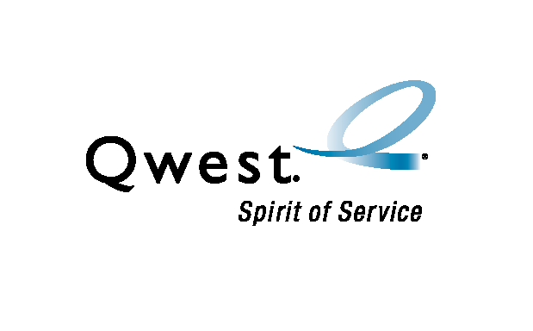
Super DaVaR upgrades

Meeting Minutes

Details | Date: Friday, October 31, 2003  Time: 1:00 PM MST  Place: 700 W. Mineral – Room 101E or 877-564-8688 id:278-1727

Attendees | - Ken Koch – Process Analyst  - Dave Bosley – Staff Engineer (Statistical Analysis)  - Lance King – Network Planning (LQSM)  - Art Utech – FLUKE (Regional Acct Mgr)  - John Settembre – AZ (Manager) | - Cynthia Parker – AZ (DaVaR SPOC)  - Al Lundy – AZ (DaVaR Tech)  - Will Finley – OR (DaVaR Tech)  - Matt Klump – OR (DaVaR Tech)  - Cliff Randle – UT (DaVaR Tech)

Purpose | Communicate status for upgrading DaVaRs

Summary | The following information was updated during the meeting.
 | Topic | Information
 | Super DaVaR trial | Discovered that Super DaVaR settings for detecting ‘busy’ and ‘faults’ needed to be adjusted. FLUKE has determined correct settings and testing will begin 11/3 in DNVRCOCL and SCDLAZMA to trial new settings. SPRSAZMA will also be redone as part of retest to determine whether to continue with Super DaVaR option.  Fault detect – changed from 1040K ohms to 3.5M ohms  Busy detect – changed from 46 volts to 48 volts  NOTE: Hope I represented the fault and busy detects correctly.
 | IT Qwest Image for Super DaVaR | Qwest Image loaded on Colorado’s Super DaVaR.  Modem driver fixed – 10/31, still need port driver fixed.
 | Super DaVaR XP | XP process for creating Super DaVaR program to correct load coil information in LFACS and OSP-FM is on schedule to complete in the first 90-day iteration – due 01/29/04.

Actions items | The following actions are required.
 | Topic | Who’s Responsible | Due
 | DaVaR inventory/techs (received most) | Each State to Ken Koch | 09/19/2003
 | Complete Qwest Image for DaVaR | Ken Koch / Roy Gonzalez | 11/14/2003
 | Update Super DaVaR with new tables | Ken Koch | 11/07/2003

Next meeting | Friday, November 7, 2003  1 PM – 2 PM MST  Mnrl: 101E or 877-564-8688 id: 278-1727

